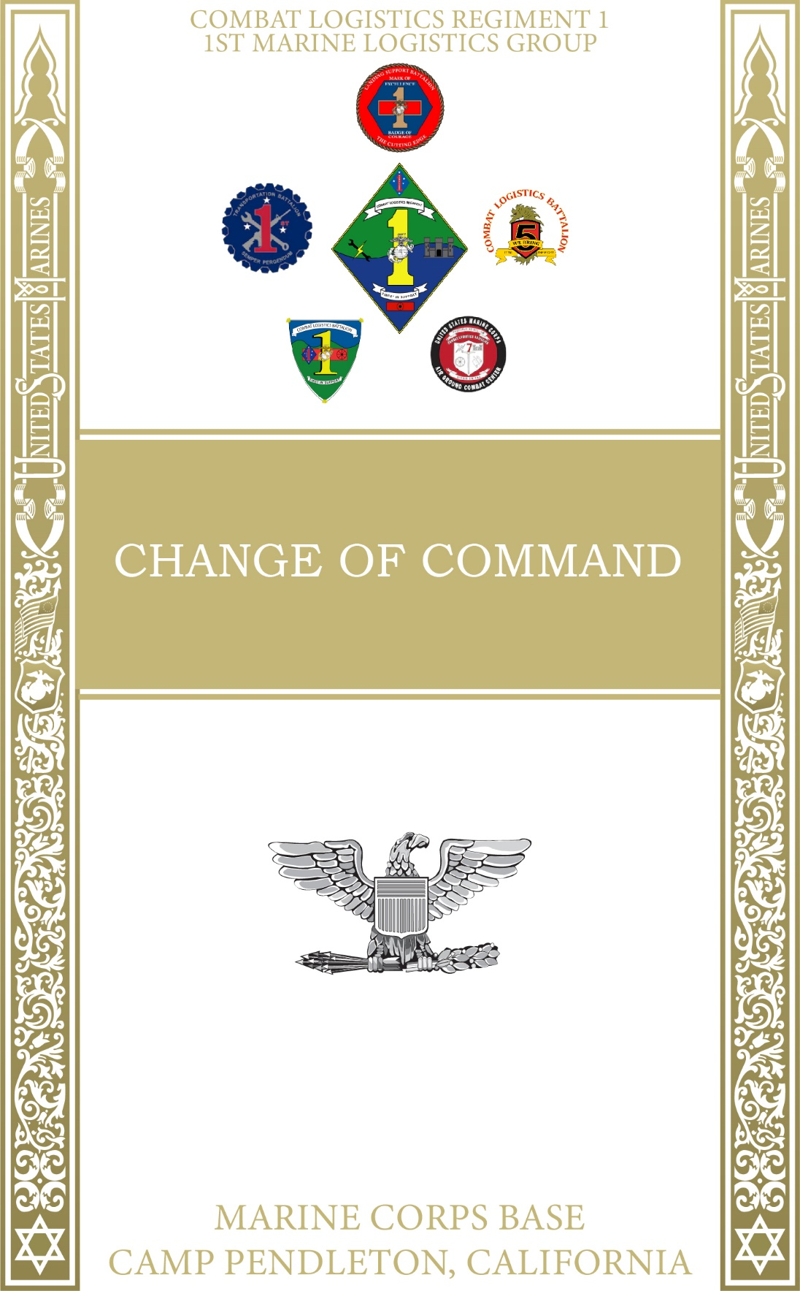

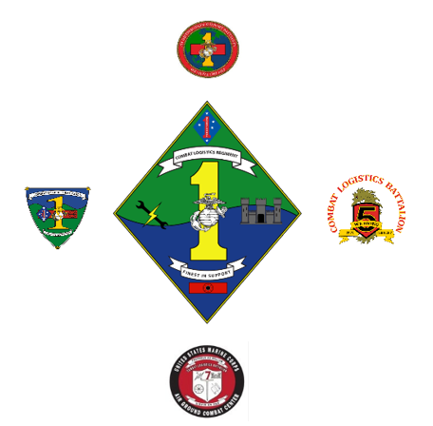

COLONEL COLONEL

B. P. PLUAS P. N. WILSON

12 JUNE 2024

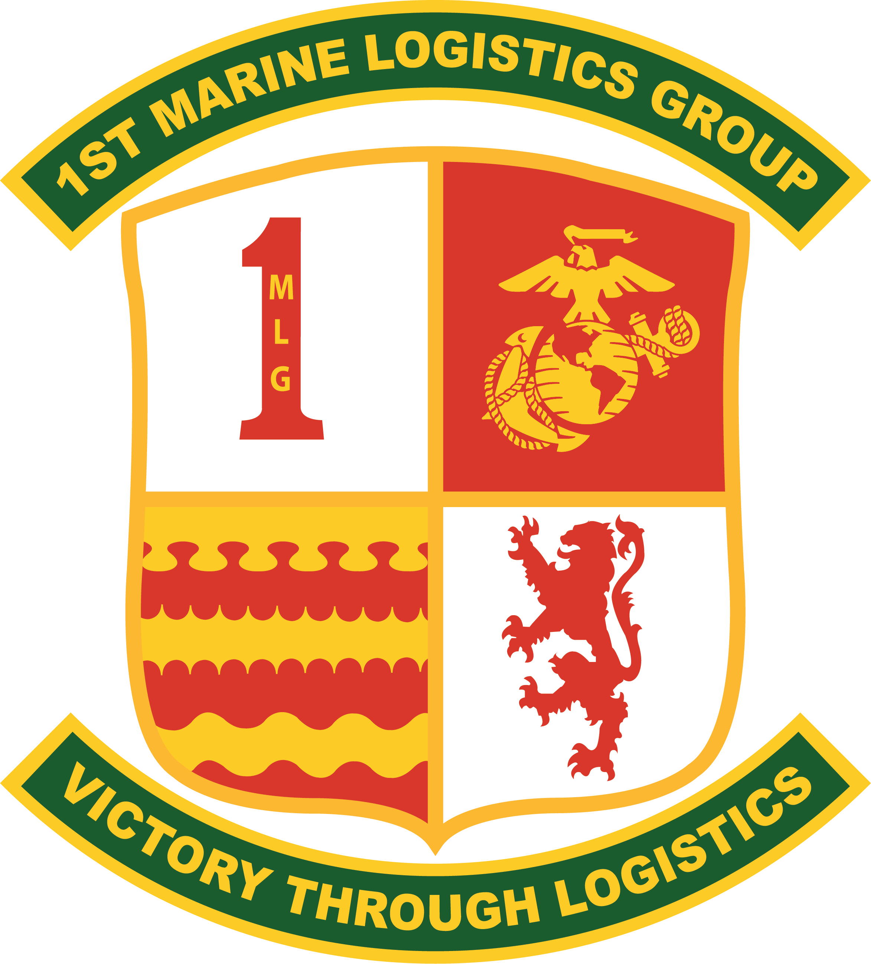

*The*

*Commanding General of*

*1st Marine Logistics Group*

*welcomes you to the*

*Change of Command*

*during which*

*Colonel Prescott N. Wilson*

*will relinquish his post to*

*Colonel Bolivar P. Pluas*

SEQUENCE OF EVENTS

*Pre-Parade Serenade*

*Staff Forms*

*Invocation*

*Sound Attention*

*Adjutant’s Call*

*March On*

*National Anthem*

*Post the Colors*

*Sound Off*

*Report*

*Publish the Order*

*Officers Center*

*Box the Staff*

*Change of Command*

*Pass in Review*

*Anchors Aweigh and the Marines’ Hymn*

*Reception*

# LINEAGE

1942 – 2023

1942 - 1949

# Activated 7 February 1942 at Marine Barracks, New River, North Carolina, as

# 1st Pioneer Battalion and assigned to 1st Marine Division

# deployed during July 1942 to Wellington, New Zealand

# participated in the following World War II campaigns:

# Guadalcanal

# Eastern New Guinea

# Bismarck Archipelago

# Western Carolines

# Okinawa

# Redesignated 12 January 1943 as 2d Battalion, 17th Marines

# Redesignated 30 June 1944 as 1st Pioneer Battalion

# Deployed during September 1945 to Tientsin, China

# Relocated during June 1947 to Camp Joseph H. Pendleton, California

# Redesignated 1 October 1947 as 1st Shore Party Battalion

# 1950 - 1957

# Deployed during August 1950 to Kobe, Japan

# Redeployed during September 1950 to the Republic of Korea

# Participated in the Korean War, September 1950 - July 1953

# Participated in the Defense of the Korean Demilitarized Zone, Korea

# August 1953 - March 1955

# Relocated during April 1955 to Camp Pendleton, California

# Deactivated 17 June 1957

# 1964 - 1975

# Reactivated 1 July 1964 at Camp Pendleton, California, as

# 1st Shore Party Battalion and Assigned To 1st Marine Division

# Deployed during August 1965 to Camp Hauge, Okinawa

# Redeployed during January 1966 to the Republic of Vietnam

# Participated in the war in Vietnam, January 1966 - March 1970

# Relocated during March 1970 to Camp Pendleton, California, and

# reassigned to 5th Marine Amphibious Brigade

# Reassigned during April 1971 to 1st Marine Division

# 1976 -2018

# Redesignated 30 March 1976 as Headquarters and Service Battalion and reassigned to 1st Division Support Group, 1st Marine Division

# Redesignated 1 April 1979 as 1st Landing Support Battalion and

# reassigned to 1st Force Service Support Group

# Participated in operations Desert Shield and Desert Storm,

# Southwest Asia, December 1990 - April 1991

# Elements participated in Operation Provide Comfort, Iraq,

# April - May 1991

# Participated in Operation Restore Hope, Somalia,

# December 1992 -February 1993

# Redesignated 18 December 1998 as 1st Transportation Support Battalion

# Redesignated during 2003 as Combat Service Support Group 11

# Participated in Operation Iraqi Freedom, Iraq,

# 

# March - May 2003, August 2004 - February 2005 and

# February 2008 - September 2009

# Redesignated during March 2005 as Combat Logistics Regiment 1

# 1st Force Service Support Group redesignated During October 2005

# as 1st Marine Logistics Group

# Elements participated in Operation Iraqi Freedom, Iraq,

# February 2006 - February 2007

# Elements participated in Operation Enduring Freedom, Afghanistan,

# September 2009 - December 2011 and January - October 2014

# HONORS

BRIGADIER GENERAL ANDREW M. NIEBEL

UNITED STATES MARINE CORPS

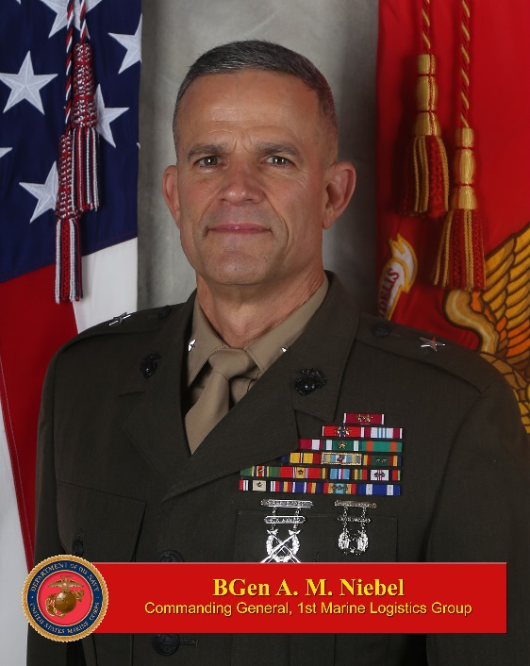

Brigadier General Niebel was born in Bethesda, Maryland. He graduated from East Stroudsburg University in 1989 and was commissioned through the Officer Candidates Course program in 1992. Following his initial training as a Combat Engineer Officer, he held a variety of billets in the Fleet Marine Force, supporting establishment and the joint community.

His Fleet Marine Force assignments include Platoon and Company Commander at 7th Engineer Support Battalion; Engineer Detachment Commander at MEU Service Support Group-11 (Operation’s Southern Watch and Vigilant Sentinel); Engineer Support Element Officer at the 1st Force Service Support Group; Company Commander, Assistant Operations Officer, and Battalion Executive Officer at 2d Combat Engineer Battalion; Deputy Counter Improvised Explosive Device Division with II MEF Forward (Operation Iraqi Freedom 06-08); Commanding Officer of 1st Combat Engineer Battalion (Operation Enduring Freedom 10.2 and 12.1); Commanding Officer of Combat Logistics Regiment-27; and Chief of Staff, 2d Marine Logistics Group.

His other assignments include Command Section lead, Company Commander, and Assistant Operations Officer at The Basic School; J-4 Engineer Plans Officer and Exercise Related Construction Program Manager for United States Pacific Command; Senior Fellow in the Chief of Naval Operations Strategic Studies Group (34) in Newport, RI; and Chief of Staff of Marine Corps Installations Command, HQMC at the Pentagon.

Brigadier General Niebel’s most recent assignment was Commanding General, Marine Corps Installations East/Marine Corps Base, Camp Lejeune, NC. He assumed his current duties as Commanding General, 1st Marine Logistics Group in July 2023.

He is a graduate of the Amphibious Warfare School, Marine Corps Command and Staff College, Naval War College, and United Kingdom’s Higher Command and Staff Course. He holds master’s degrees in Organizational Management, and National Security and Strategic Studies.

Brigadier General Niebel and his wife Joann have three daughters, Raeann, Hannah, and Andrea.

COLONEL PRESCOTT N. WILSON

UNITED STATES MARINE CORPS

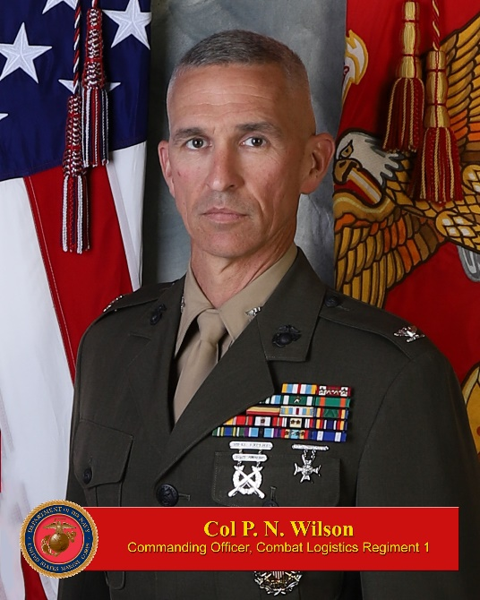

Colonel Wilson is a native of Plano, TX. He graduated from Texas A&M and was commissioned a Marine Second Lieutenant in 1998.

Colonel Wilson’s service in the operating forces include: Engineer Platoon Commander, 2nd CEB (April 1999 – November 2000); Bn Engineer Officer and Security Platoon Commander (November 2000 – June 2002); Engineer Company Commander, CLB 5.2 (July 2006 – March 2007, Operation Iraqi Freedom); Operations Officer, Combat Logistics Battalion 11 (March 2007 – July 2008, 11th MEU WESTPAC); Division Engineer Officer and Plans Officer, 1st Marine Division (July 2008 – Feb 2009); Operations Officer, 1st Combat Engineer Battalion (Feb 2009 – December 2009, Operation Enduring Freedom); Assistant Current Operations Officer, 1st Marine Division (December 2009 – June 2010); Plans Officer, III MEF G-5 (August 2011 – June 2014); Plans Officer, III MEF G-35 (August 2016 – April 2017); Commanding Officer, Marine Wing Support Squadron 172 (May 2017 – May 2019); A/CS G-3, 1st Marine Logistics Group (July 2022 – January 2023).

Outside the operating forces, Colonel Wilson’s service includes Warfighting Instructor, Staff Platoon Commander, and Company XO, The Basic School (July 2002 – June 2005); Head, Readiness Section, Readiness Branch (POR), PP&O (July 2014 – June 2016); Division Chief, NATO and Turkey Policy Division, Joint Staff J-5 (June 2020 – June 2022).

Colonel Wilson has attended various schools and courses, including Officers Candidates School (PLC); The Basic School; Combat Engineer Officer’s Course; Light Armored Reconnaissance Leaders Course; Summer Mountain Leaders Course; Expeditionary Warfare School; Marine Corps Command and Staff College (non-resident); School of Advanced Warfighting; Red Team Member Training; Joint Logistics Officers Course; and the National War College.

Colonel Wilson is married and has two children.

COLONEL BOLIVAR P. PLUAS

UNITED STATES MARINE CORPS

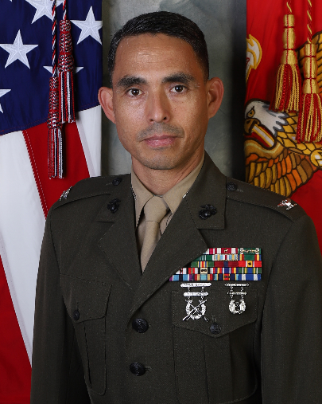

Colonel Patrick Pluas, a native of Queens, New York, enlisted in the Marine Corps in May 1992. In April 1999, he was commissioned as a Second Lieutenant. He graduated from California State University Fullerton, California.

He was first assigned to the 1st Marine Division, Camp Pendleton, CA and served as the Battalion Supply Officer, 2nd Battalion, 5th Marines. He deployed with the 31st MEU Battalion Landing Team to Okinawa, Australia, and East Timor.

In February 2003, he reported to Combat Service Support Group – 3, Marine Corps Base, Hawaii and served as General Account OIC, the S-4 Officer, and Headquarters and Service Company Commander. In July of 2005, he deployed to Baghdad, Iraq where he was part of the joint staff in the Logistics Directorate of the Multi-National Forces, Iraq.

In May 2006, he reported to Headquarters and Service Battalion, Marine Corps Base, Okinawa, Japan, and served as the Alpha Company Commander. He also served as the Battalion Operations Officer and Base G-4 Operations Officer.

In June 2010, he reported to I Marine Expeditionary Force, Advisor Training Group and deployed to Helmand Province, Afghanistan as a Team Leader and Senior Advisor to an Afghan Border Police Battalion. Upon his return to Camp Pendleton in May 2011, he was assigned to 1st Supply Battalion, Combat Logistics Regiment 15, and took command of Supply Company.

In September 2011, he was reassigned to 1st Maintenance Battalion, Camp Pendleton as the Battalion Operations Officer and deployed to Afghanistan in March 2012 in support of Operation Enduring Freedom 12-1. Upon his return to Camp Pendleton in October 2012, he returned to 1st Supply Battalion as the Executive Officer.

He was promoted to Lieutenant Colonel in June 2016 and commanded Combat Logistics Battalion 3 in Hawaii from June 2016 to June 2018. He was then selected to attend the Naval War College in Newport, Rhode Island.

In Dec 2018, he was selected to the Marine Attaché Program and served two years (2020 to 2022) as the Marine Attaché (MARA), Defense Attaché Office, Bogota Colombia.

In Aug 2022, Col Pluas was assigned to the 1st Marine Division, where he currently serves as the Blue Diamond G-4, Assistant Chief of Staff.

He served as the Aide-de-Camp to the I Marine Expeditionary Force Commanding General from March 2013 to July 2014. He is a 1999 graduate of the Ground Supply Officer Course, a 2006 resident graduate of the Marine Corps Expeditionary Warfare School, a 2012 nonresident graduate of the Marine Corps Command and Staff College, a 2015 resident graduate of La Escuela de Guerra Naval (Naval War College in Argentina), a 2019 graduate of the Naval War College, and a 2019 Graduate of the Joint Military Attaché School. He has a master’s degree in economics from the University of Oklahoma.

His personal decorations include the Defense Meritorious Service Medal (Second Award), the Meritorious Service Medal (2nd award), the Navy and Marine Corps Commendation Medal (6th Award), and the Army Commendation Medal.

Marines’ Hymn

From the Halls of Montezuma,

To the shores of Tripoli;

We fight our country’s battles

In the air, on land, and sea.

First to fight for right and freedom

And to keep our honor clean;

We are proud to claim the title of

UNITED STATES MARINES.

Our Flag’s unfurled to every breeze

From dawn to setting sun;

We have fought in every clime and place

Where we could take a gun;

In the snow of far off northern lands

And in sunny tropic scenes;

You will find us always on the job;

THE UNITED STATES MARINES.

Here’s health to you and to our Corps

Which we are proud to serve;

In many a strife we fought for life

And never lost our nerve;

If the Army and the Navy

Ever look on Heaven’s scenes;

They will find the streets are guarded by

UNITED STATES MARINES.

