Mailing Restrictions

There are SOME items that CAN’T be sent using the United States Postal System.

Some of these items are (but not limited to):

- Alcoholic Beverages
- Flammable Material or Fireworks
- Hazardous Material
- Weapons (restrictions apply)

International countries and APO/FPO addresses have their own individual restrictions. Contact your serving post office to find out if your item is restricted.

Packaging and Weight Restrictions

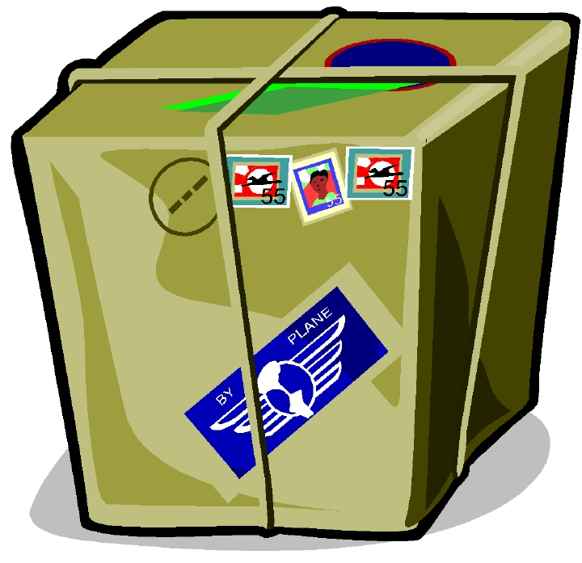
- In order to ensure your item doesn’t get damaged while in transit, packaging is very important.

- Recommend Nylon Filament tape or mailing tape. The use of masking tape, scotch or cellophane tape is NOT authorized.

- Place liquid items, such as salsa, lotion and beverages in separate zip lock bags.

- Always use the SMALLEST BOX possible. Use bubble wrap or Styrofoam popcorn to empty spaces to prevent movement and shaking.

- The maximum weight for mail is 70 pounds.

FREE Postal Supplies

USPS provides FREE shipping supplies which include the following:

- 10 priority boxes
- 10 mailing labels
- 10 customs forms
- 1 roll of bubble wrap
- 1 roll of priority tape

The FREE shipping supplies are mailed directly to your home!

- Ask for the MILITARY PACKAGE
- Call 1-800-610-8734
- Visit www.usps.com

Flat Rate Box ($8.95)

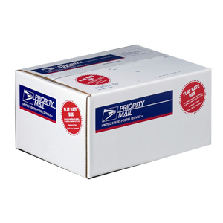
USPS has a FLAT RATE priority box that you pay only $8.95 regardless of weight (up to 70 lbs maximum) mailed to any DOMESTIC address (to include APO/FPO, U. S. territories and possessions).

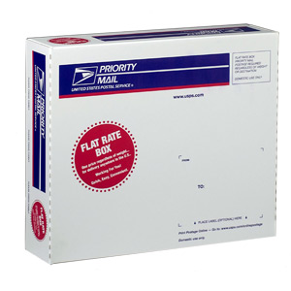

Consolidated Post Office
C a m p P e n d l e t o n C A

Updated Jan 2003



PRE-DEPLOYMENT

POSTAL BRIEF



UPDATED 8 JAN 2006

We are here for YOU!


The Consolidated Post
Office takes pride in its
efforts to give you the
finest postal service to you
and ensuring all your mail
is delivered as expeditiously
as possible around the world.
The following information is provided to assist in getting your letters and packages to your Marines and Sailors deployed overseas.

Postal Operations 725-5895
Postal Administration 763-1196
POSTAL PHONE NUMBERS

Customs Forms

The use of customs form is a requirement by the United States Customs Service and international countries.

- The customs forms are free and available at your serving post office.

- All parcels being sent TO, FROM or BETWEEN an APO/FPO must bear a customs form.

- To assist customs and prevent damage to your package, include KEY or LOCK COMBINATION when mailing sea-bags, foot lockers etc.

- Customs forms must be filled out in DETAIL.

Types of Mail

There are a variety of services available to send your mail.

- All mail weighing OVER 16 OUNCES must be presented to a post office for mailing.

- Each service is priced differently by weight, size, and destination zip code.

- The speed in which the item is handled varies according to the service and destination.

FIRST CLASS / PRIORITY (average 7-10 days) This service is the fastest means of delivery for sending items over to the deployed address. You can mail items that weigh up to 70 lbs.

PARCEL POST (average 2 to 3 weeks) This service is the slowest and cheapest means of delivery. You can mail items that weigh up to 70 lbs.

MOTOMAIL Motivational Mail (MotoMail) is a FREE Internet-based letter delivery service. Log onto www.motomail.us for more information.

Extra Services

Extra services provide an additional service for a fee. Each one has a specific service that is provided.

- INSURANCE: HIGHLY RECOMMENDED when mailing items of value. Insurance can only be purchased at the time of mailing and provides up to $5000 insurance for a lost, rifled or damaged article. Insurance is VERY INEXPENSIVE.

- CERTIFIED: Certified provides the mailer with a receipt, and a record of delivery at its destination.

- RETURN RECIEPT: It can be purchased at the time of mailing for $2.15 or after mailing for $3.80. This service provides the sender with a date of delivery and addressee (or agent) signature.

Address Format


To ensure prompt and accurate delivery of your mail; the proper format for your return and delivery address are of the UTMOST IMPORTANCE
and can not be over emphasized. When
mailing out any item you must use the
proper deployed overseas military address.
The format is displayed below:

ADDRESS FORMAT

Line 1 Rank and Complete Name
Line 2 Command (Battalion / Section)
Line 3 Unit Number (5-digits)
Line 4 FPO AP XXXXX-XXXX

SAMPLE ADDRESS
Sgt Ben N. Toolong
Marine Detachment 1

Unit #####
FPO AP #####-####

NEVER CHANGE YOUR DEPLOYED ADDRESS GIVEN TO YOU BY
POSTAL MARINES!
BARRACKS MARINES
Update your mailing address via Marine Online (MOL)

